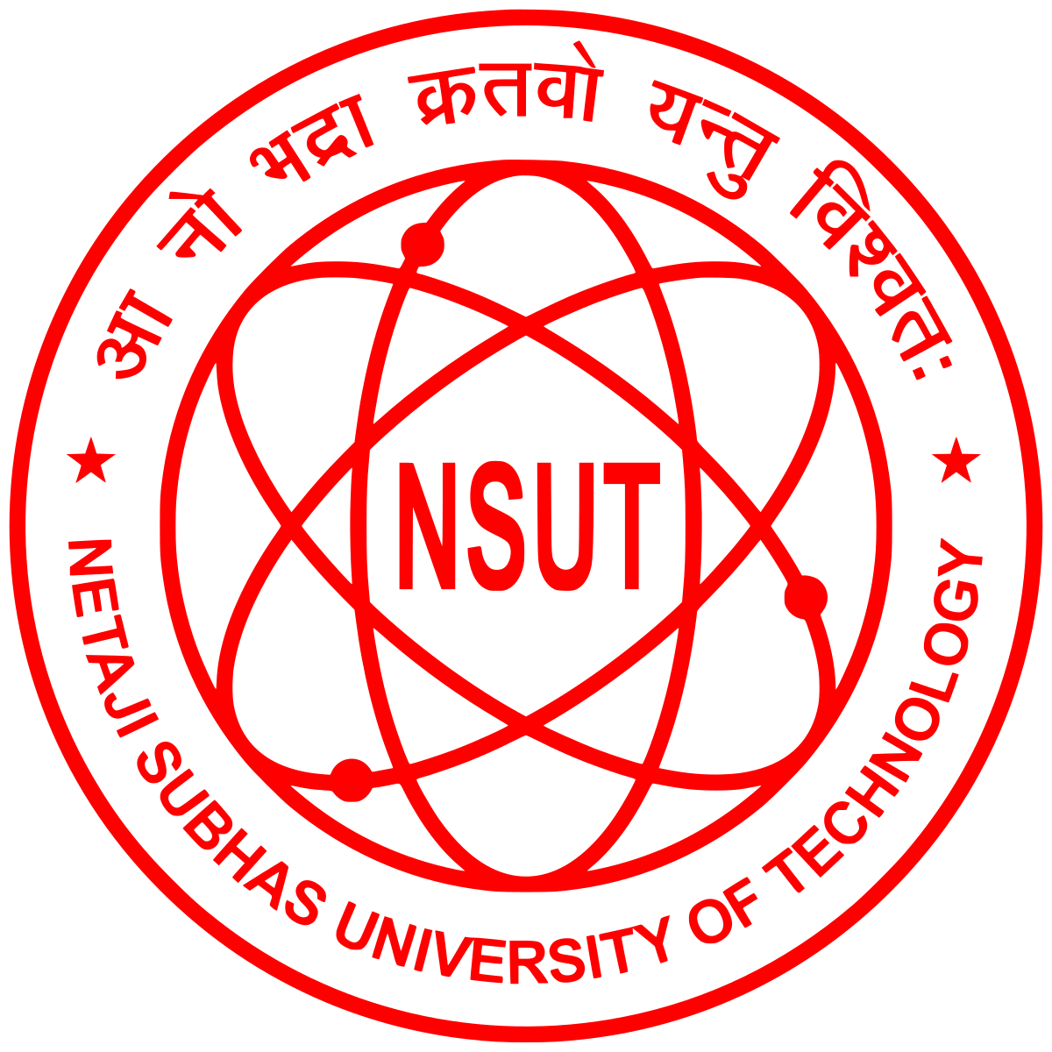
VANSH BHARDWAJ
Delhi, IN | vansh.bhardwaj.ug23@nsut.ac.in | +91-9958413469

Leetcode | GitHub | LinkedIn | GeeksforGeeks
EDUCATION

Year | Course | Institute | Grade
2023-2027 | B.Tech (Information Technology) | Netaji Subhas University of Technology | 8.65
2021-22 | Class XII, CBSE Board | Lawrence Public School, New Delhi | 96.8%
2019-20 | Class X, CBSE Board | Lawrence Public School, New Delhi | 93.8%

Data Science Intern - IndiGo June 2026 - Present
EXPERIENCE
- Developing a multi-class Machine Learning model to classify Mandatory Occurrence Reports (MORs) from incoming Flight Safety incident reports, improving incident triaging and regulatory compliance.
- Developing scalable data pipelines and workflow automation solutions to transform unstructured aviation safety reports into structured insights while ensuring DGCA regulatory compliance.

PROJECTS
ERiCA | (Python, LangGraph, win32com, Pandas, OpenPyXL, Pathlib,OS, Datetime/Time, TypedDict)
- Designed and developed ERiCA, a LangGraph-powered autonomous AI agent for automated aviation safety report classification using ERCS, ARMS, and 5x5 risk assessment frameworks.
- Built a modular LangGraph StateGraph workflow comprising queue management, intent classification, validation, and execution agents for reliable end-to-end processing.

Smart Traffic Light Control System | (Python, OpenCV, YOLOv8, NumPy, Pygame, Matplotlib, Pandas)
- Developed a Computer Vision-based smart traffic management system using YOLOv8 and OpenCV to dynamically optimize traffic signal timing based on real-time vehicle density.
- Implemented emergency vehicle prioritization (Green Corridor) logic to reduce emergency response delays and improve traffic efficiency by approximately 80%.

CERTIFICATIONS
Amazon ML Summer School 2025 | Amazon India
- Selected among top 3000 applicants out of 60k+ participants nationwide for an intensive, invite-only training program focused on advanced machine learning topics.
Google AI Essentials | Google
- Completed Google's AI Essentials program covering Prompt Engineering, Generative AI, Responsible AI, LLM applications, and AI-assisted productivity workflows.

SKILLS

Languages : C++, Python, Java, MySQL, HTML5, CSS, JavaScript
Developer Tools : Git/GitHub, VS Code, PyCharm, Figma, Canva, MATLAB
Relevant Coursework : OS, DBMS, Computer Networks, OOPs, DSA, Design & Analysis of Algorithms

POSITIONS OF RESPONSIBILITY
President - Enactus NSUT
- Leading Enactus NSUT, a 120-member organization, by overseeing strategic planning, project execution, stakeholder coordination, and representing the college at the Enactus India National Exposition 2024 and 2025.
- Led Project Srijan by managing a cross-functional team of 20+ members, delivering 500+ customized calendars and executing multiple corporate orders while ensuring timely project delivery.
Director - Nalum (Alumni Society of NSUT)
- Managing alumni database operations for 5000+ alumni while coordinating networking events through Nalum’s website.
- Organized Alumni Meet-2025 & Silver Jubilee Function leading a team of 100+ volunteers.

ACHIEVEMENTS
- Solved 350+ Data Structures & Algorithms problems across different coding platforms.
- Secured Department Rank 1 in the 5th and 6th semesters with SGPAs of 9.33 and 9.17 respectively.

